Purpose: Day 10 Classwork and Assignment
Date: 05/01/2026
Author: Vinayak Majhi
ID: 58618
Batch ID: 25SUB4505 - DATACOM+5G

ClassWork

Q.1 Implement your own cat program, which will take file name as an argument and print the contents of the file on the screen.

// Purpose: Custom cat command implementation in C++
// Date: 05/01/2026
// Author: Vinayak Majhi
// ID: 58618
// Batch ID: 25SUB4505 - DATACOM+5G

#include <fstream>
#include <iostream>

using namespace std;

int main(int argc, char *argv[]) {
if (argc != 2) {
cout << "Usage: " << argv[0] << " <filename>" << endl;
return 1;
}

ifstream fin(argv[1]);
if (!fin) {
cout << "Error opening file" << endl;
return 1;
}

char ch;
while (fin.get(ch)) {
cout << ch;
}

fin.close();
return 0;
}

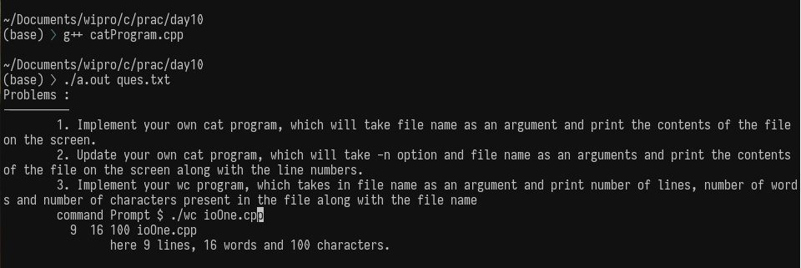

Q 2. Update your own cat program, which will take -n option and file name as an arguments and print the contents of the file on the screen along with the line numbers.

// Purpose: Custom cat command with line numbers (-n option)
// Date: 05/01/2026
// Author: Vinayak Majhi
// ID: 58618
// Batch ID: 25SUB4505 - DATACOM+5G

#include <cstring>
#include <fstream>
#include <iostream>

using namespace std;

int main(int argc, char *argv[]) {
if (argc != 3 || strcmp(argv[1], "-n") != 0) {
cout << "Usage: " << argv[0] << " -n <filename>" << endl;
return 1;
}

ifstream fin(argv[2]);
if (!fin) {
cout << "Error opening file" << endl;
return 1;
}

char ch;
int line = 1;
cout << line << " ";

while (fin.get(ch)) {
cout << ch;
if (ch == '\n') {
line++;
cout << line << " ";
}
}

fin.close();
return 0;
}

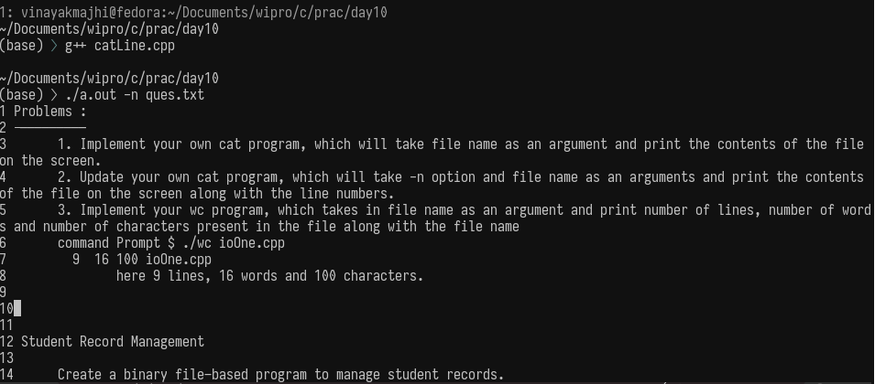

Q.3 Implement your wc program, which takes in file name as an argument and print number of lines, number of words and number of characters present in the file along with the file name
command Prompt $ ./wc ioOne.cpp
9 16 100 ioOne.cpp
here 9 lines, 16 words and 100 characters.

// Purpose: Custom wc command implementation in C++
// Date: 05/01/2026
// Author: Vinayak Majhi
// ID: 58618
// Batch ID: 25SUB4505 - DATACOM+5G

#include <cctype>
#include <fstream>
#include <iostream>

using namespace std;

int main(int argc, char *argv[]) {
if (argc != 2) {
cout << "Usage: " << argv[0] << " <filename>" << endl;
return 1;
}

ifstream fin(argv[1]);
if (!fin) {
cout << "Error opening file" << endl;
return 1;
}

char ch;
int lines = 0, words = 0, chars = 0;
bool inWord = false;

while (fin.get(ch)) {
chars++;

if (ch == '\n')
lines++;

if (isspace(ch))
inWord = false;
else if (!inWord) {
inWord = true;
words++;
}
}

fin.close();

cout << lines << " " << words << " " << chars << " " << argv[1] << endl;
return 0;
}

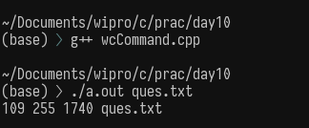

Q.4 Create a binary file–based program to manage student records containing Roll No, Name, Marks.
Operations: Create, Read, Update, Delete.

// Purpose: Student Record Management using Binary File
// Date: 05/01/2026
// Author: Vinayak Majhi
// ID: 58618
// Batch ID: 25SUB4505 - DATACOM+5G

#include <cstring>
#include <fstream>
#include <iostream>

using namespace std;

class Student {
int roll;
char name[30];
float marks;

public:
void input() {
cout << "Enter Roll No: ";
cin >> roll;
cin.ignore();
cout << "Enter Name: ";
cin.getline(name, 30);
cout << "Enter Marks: ";
cin >> marks;
}

void display() const {
cout << roll << "\t" << name << "\t" << marks << endl;
}

int getRoll() const { return roll; }

void setMarks(float m) { marks = m; }
};

void addStudent() {
Student s;
ofstream fout("student.dat", ios::binary | ios::app);
s.input();
fout.write((char *)&s, sizeof(s));
fout.close();
}

void displayAll() {
Student s;
ifstream fin("student.dat", ios::binary);
cout << "Roll\tName\tMarks\n";
while (fin.read((char *)&s, sizeof(s))) {
s.display();
}
fin.close();
}

void updateMarks(int r) {
Student s;
fstream file("student.dat", ios::binary | ios::in | ios::out);

while (file.read((char *)&s, sizeof(s))) {
if (s.getRoll() == r) {
float m;
cout << "Enter new marks: ";
cin >> m;
s.setMarks(m);
file.seekp(-sizeof(s), ios::cur);
file.write((char *)&s, sizeof(s));
break;
}
}
file.close();
}

void deleteStudent(int r) {
Student s;
ifstream fin("student.dat", ios::binary);
ofstream fout("temp.dat", ios::binary);

while (fin.read((char *)&s, sizeof(s))) {
if (s.getRoll() != r)
fout.write((char *)&s, sizeof(s));
}

fin.close();
fout.close();
remove("student.dat");
rename("temp.dat", "student.dat");
}

int main() {
addStudent();
displayAll();
updateMarks(1);
deleteStudent(1);
return 0;
}

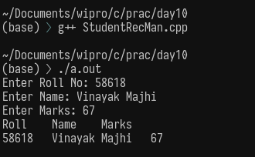

Q.5 Maintain a binary file of books with Book ID, Title, Price.
Operations: Add book, List all books.

// Purpose: Book Inventory System using Binary File
// Date: 05/01/2026
// Author: Vinayak Majhi
// ID: 58618
// Batch ID: 25SUB4505 - DATACOM+5G

#include <cstring>
#include <fstream>
#include <iostream>

using namespace std;

class Book {
int bookId;
char title[40];
float price;

public:
void input() {
cout << "Enter Book ID: ";
cin >> bookId;
cin.ignore();
cout << "Enter Title: ";
cin.getline(title, 40);
cout << "Enter Price: ";
cin >> price;
}

void display() const {
cout << bookId << "\t" << title << "\t" << price << endl;
}
};

int main() {
Book b;
ofstream fout("books.dat", ios::binary | ios::app);
b.input();
fout.write((char *)&b, sizeof(b));
fout.close();

ifstream fin("books.dat", ios::binary);
cout << "ID\tTitle\tPrice\n";
while (fin.read((char *)&b, sizeof(b))) {
b.display();
}
fin.close();

return 0;
}

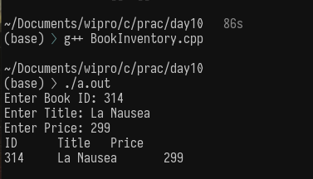

Q.6 Library Management System (Binary File)
Create a binary file–based library system supporting:

Add book
Issue book
Return book
Delete book record

// Purpose: Library Management System using Binary File
// Date: 05/01/2026
// Author: Vinayak Majhi
// ID: 58618
// Batch ID: 25SUB4505 - DATACOM+5G

#include <cstring>
#include <fstream>
#include <iostream>

using namespace std;

class Library {
int bookId;
char bookName[40];
char author[30];
bool available;

public:
void input() {
cout << "Enter Book ID: ";
cin >> bookId;
cin.ignore();
cout << "Enter Book Name: ";
cin.getline(bookName, 40);
cout << "Enter Author: ";
cin.getline(author, 30);
available = true;
}

void display() const {
cout << bookId << "\t" << bookName << "\t" << author << "\t"
<< (available ? "Available" : "Issued") << endl;
}

int getId() const { return bookId; }

void issue() { available = false; }
void ret() { available = true; }
};

void addBook() {
Library l;
ofstream fout("library.dat", ios::binary | ios::app);
l.input();
fout.write((char *)&l, sizeof(l));
fout.close();
}

void issueBook(int id) {
Library l;
fstream file("library.dat", ios::binary | ios::in | ios::out);

while (file.read((char *)&l, sizeof(l))) {
if (l.getId() == id) {
l.issue();
file.seekp(-sizeof(l), ios::cur);
file.write((char *)&l, sizeof(l));
break;
}
}
file.close();
}

void returnBook(int id) {
Library l;
fstream file("library.dat", ios::binary | ios::in | ios::out);

while (file.read((char *)&l, sizeof(l))) {
if (l.getId() == id) {
l.ret();
file.seekp(-sizeof(l), ios::cur);
file.write((char *)&l, sizeof(l));
break;
}
}
file.close();
}

void deleteBook(int id) {
Library l;
ifstream fin("library.dat", ios::binary);
ofstream fout("temp.dat", ios::binary);

while (fin.read((char *)&l, sizeof(l))) {
if (l.getId() != id)
fout.write((char *)&l, sizeof(l));
}

fin.close();
fout.close();
remove("library.dat");
rename("temp.dat", "library.dat");
}

int main() {
addBook();
issueBook(1);
returnBook(1);
deleteBook(1);
return 0;
}

